Academic Wardens - 2026

Kuliyapitiya Premises
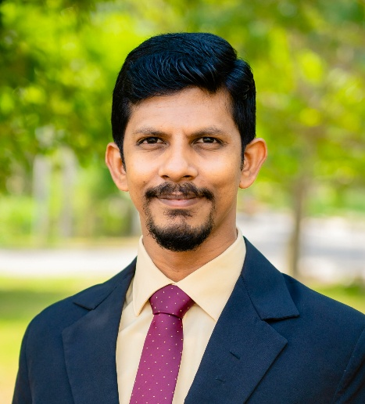

Dr. R.D.A.A Rajapaksha

Senior Lecturer Grade II

Department of Nano Science Technology

Faculty of Technology

Ph.D. in Nanoelectronics Engineering (UniMAP)

Ph.D. in Nanoelectronics (WUSL)
B.Sc.(Applied Science) (WUSL)
Mobile No. : 071-6865908
Email: asanka@wyb.ac.lk

Makandura Premises
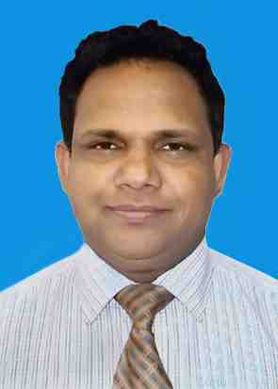

Dr. W.M.W.W. Kandegama

Senior Lecturer Grade I

Department of Horticulture & Landscape Gardening

Faculty of Agriculture & Plantation Management

PhD in Develop Nano Formulation (CCNU, China)

MSc. in Food Safety & Control (LSBU)

B.Sc in Agriculture Science Special

Mobile No. 077-9082286

Email: wishwajith@wyb.ac.lk

